Part 2 Screenshots:
Test 1: (batchSize=1--, flushintervalMs = 100)
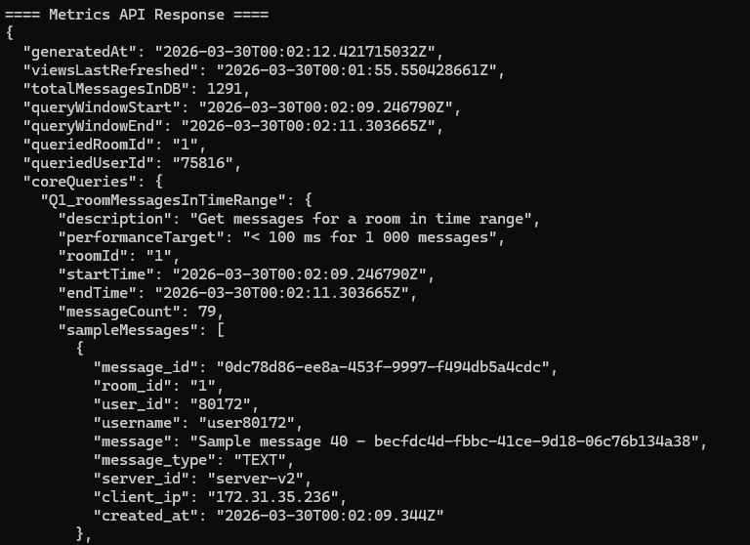
Test 2: (batchSize=500, flushIntervalMs=500)
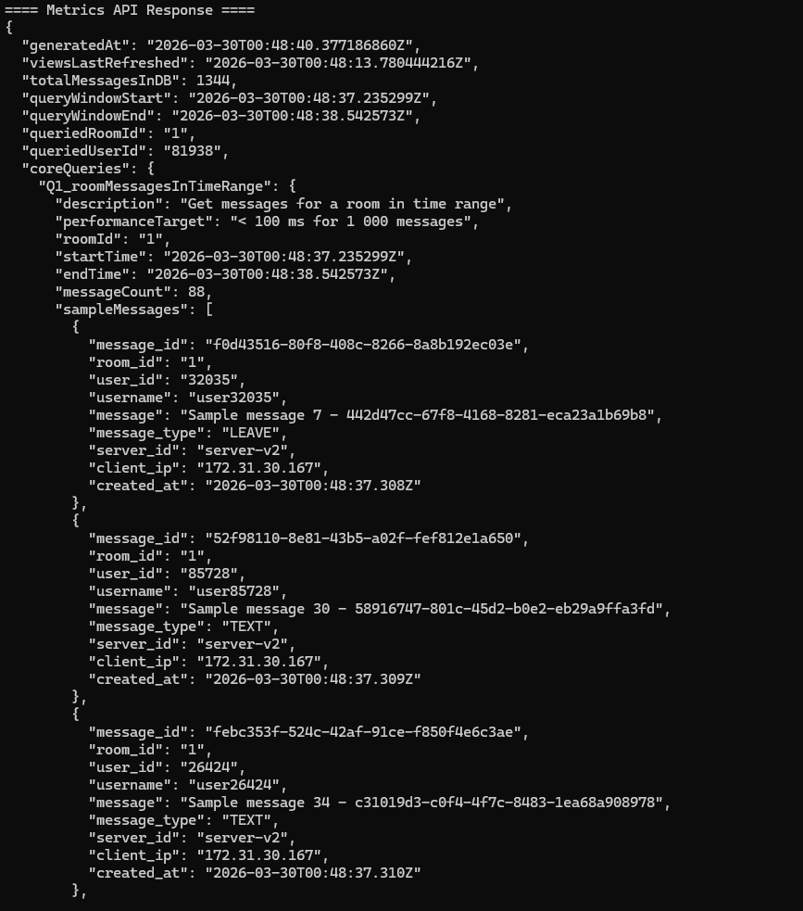 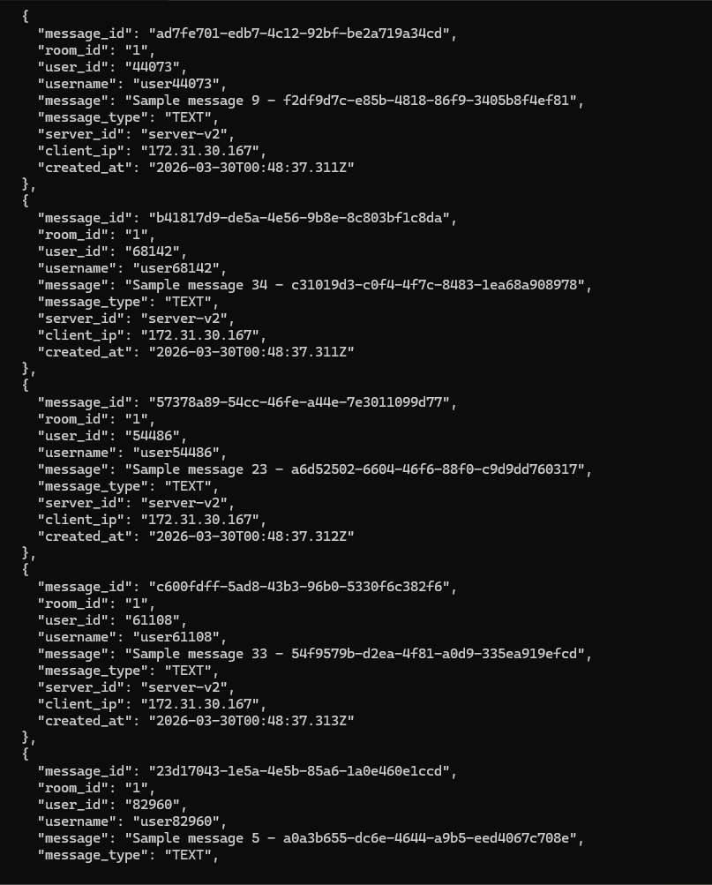 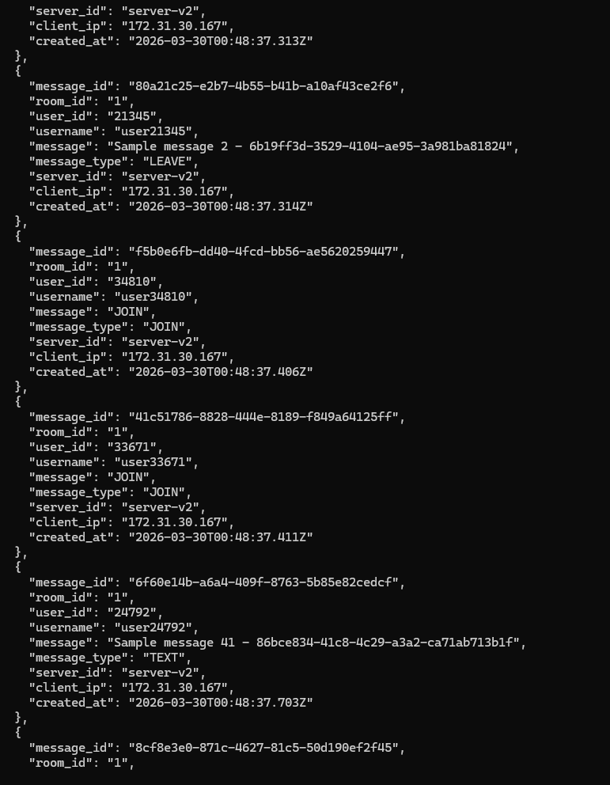 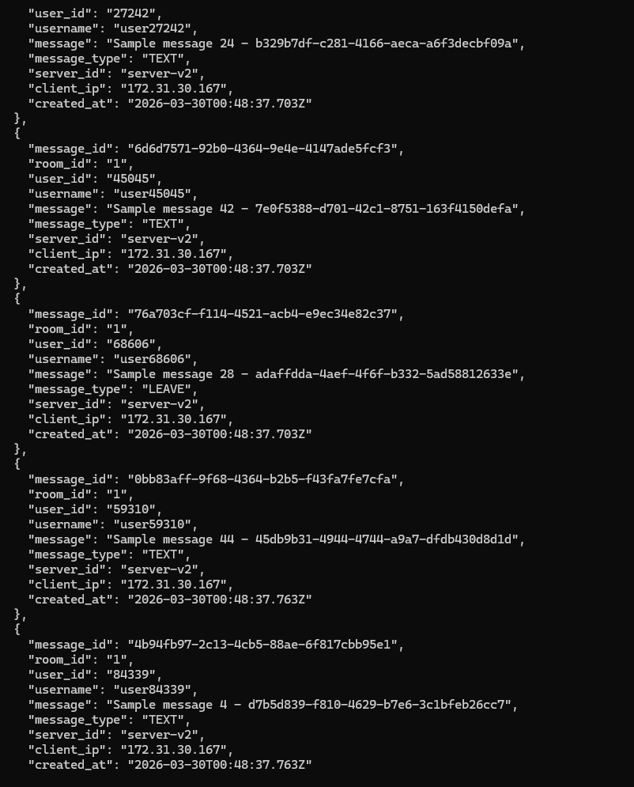 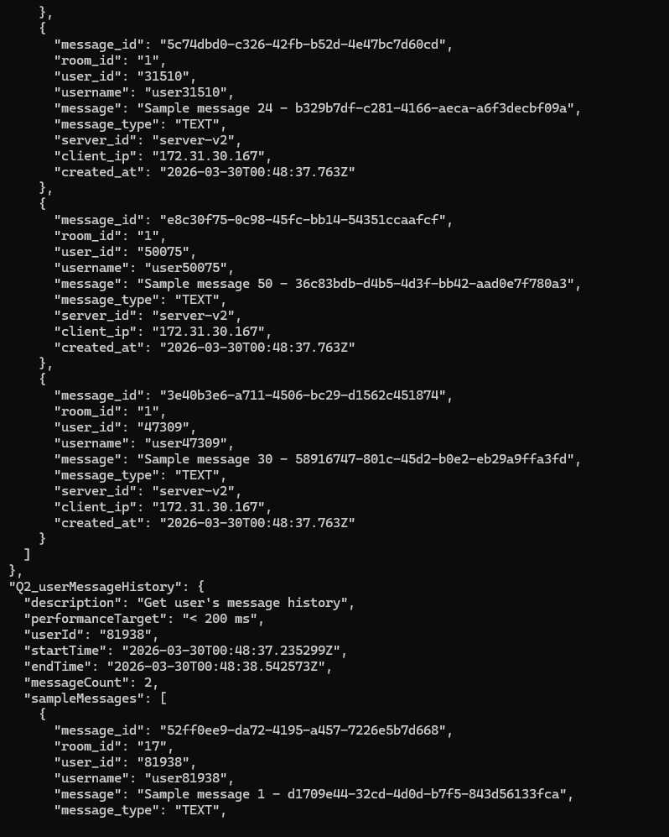 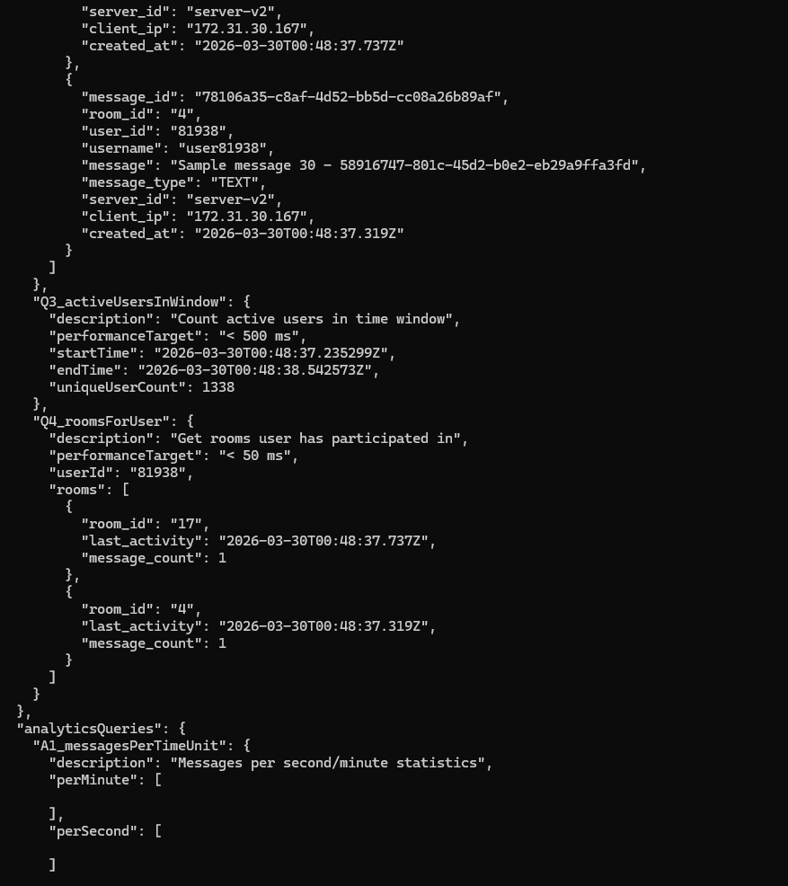 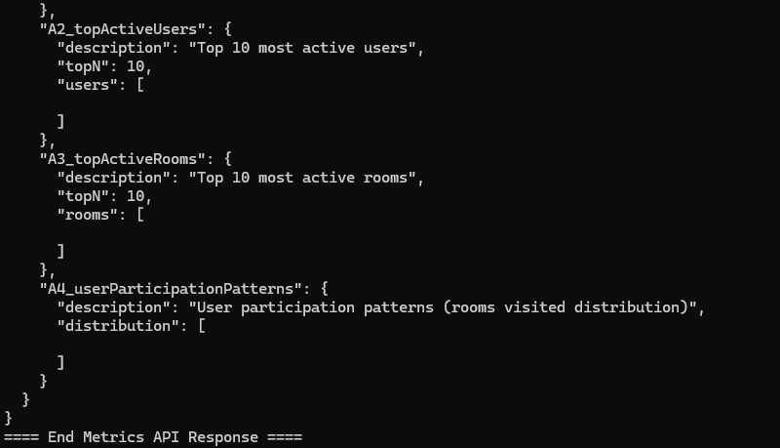
T3 Testing (batchSize: 1000, flushIntervalMs: 500, Messages published: 50,000 ):
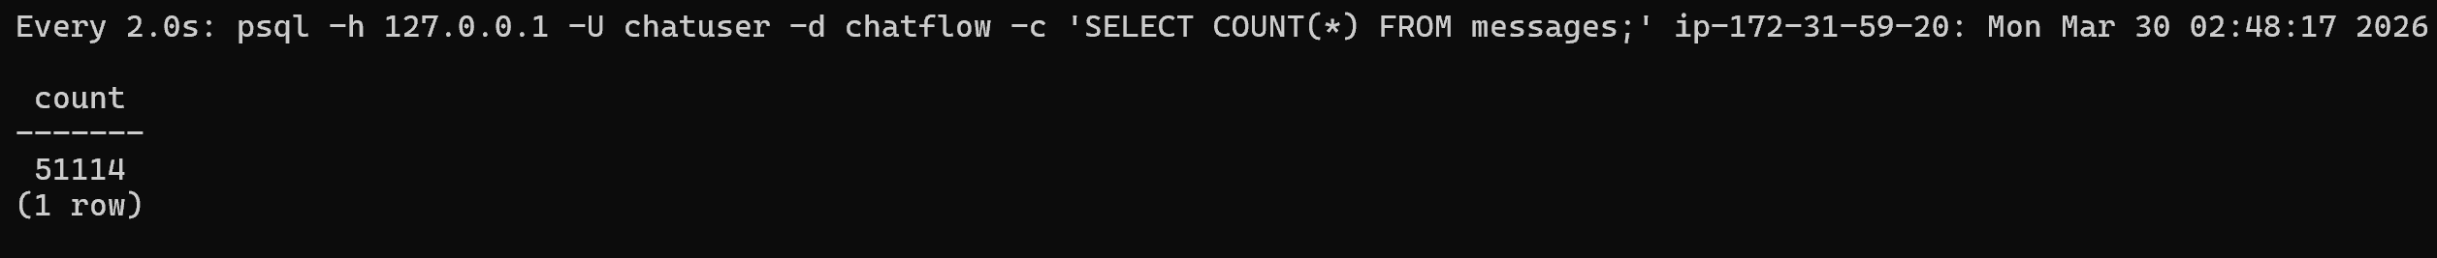 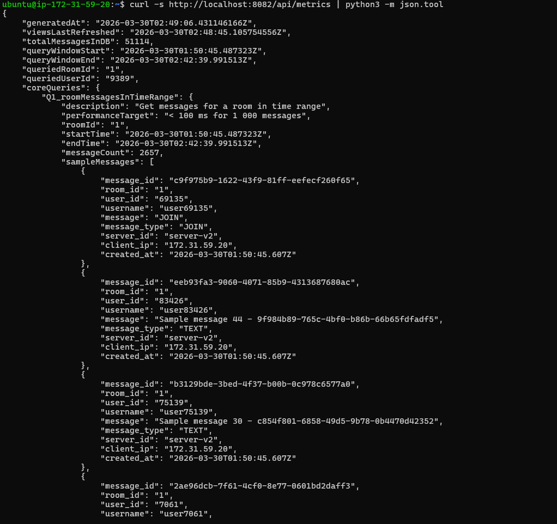 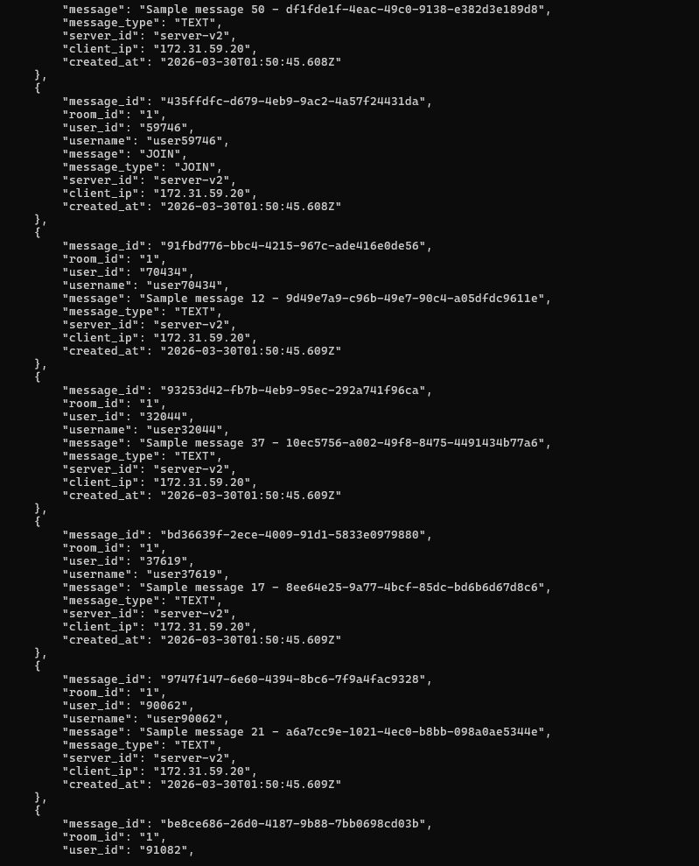 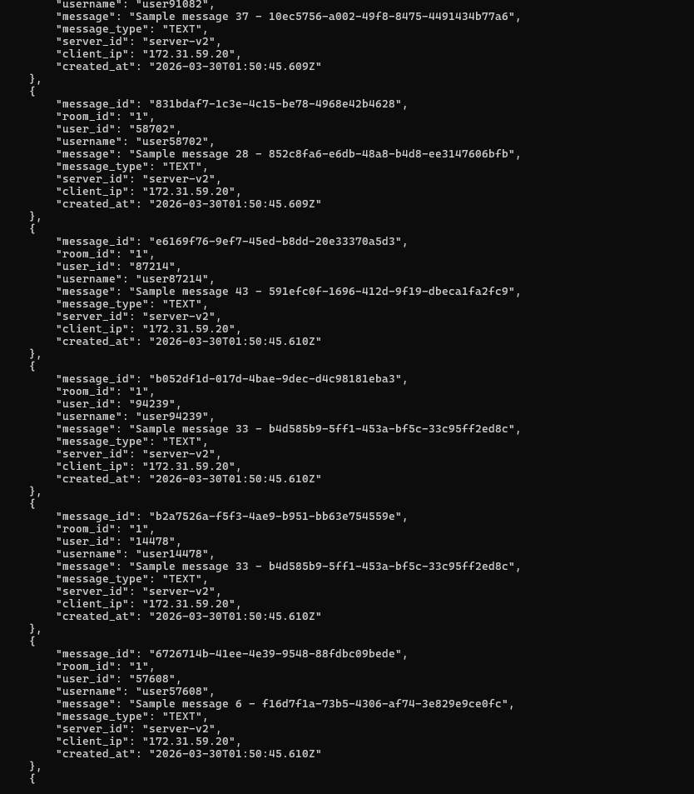 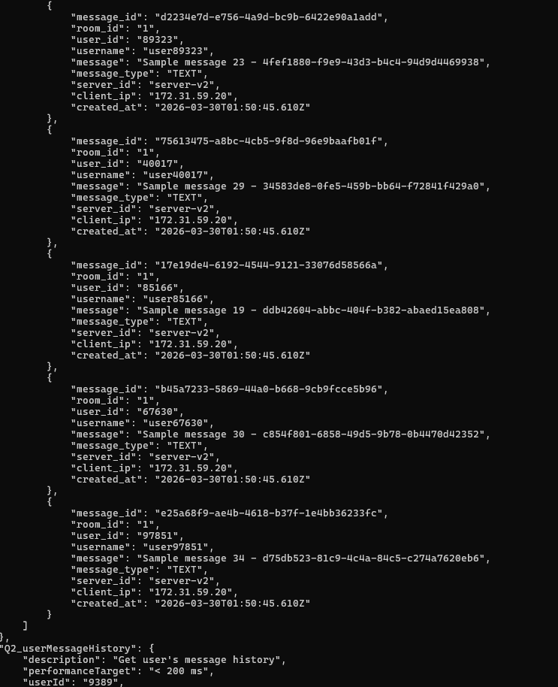 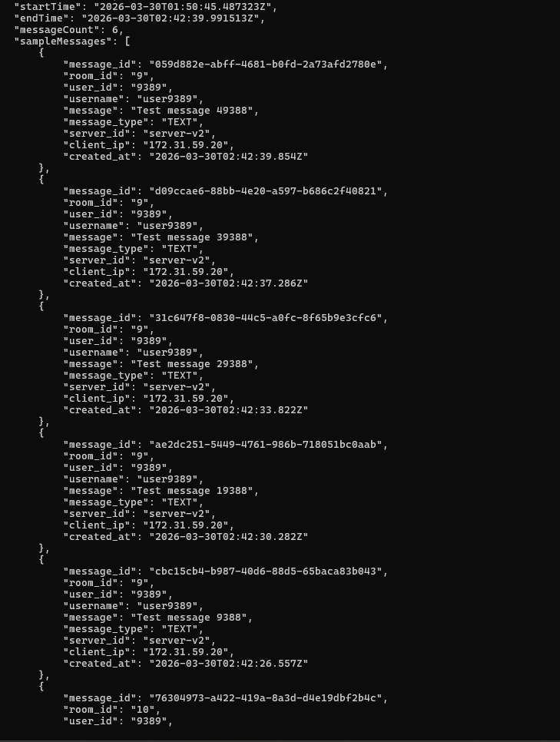 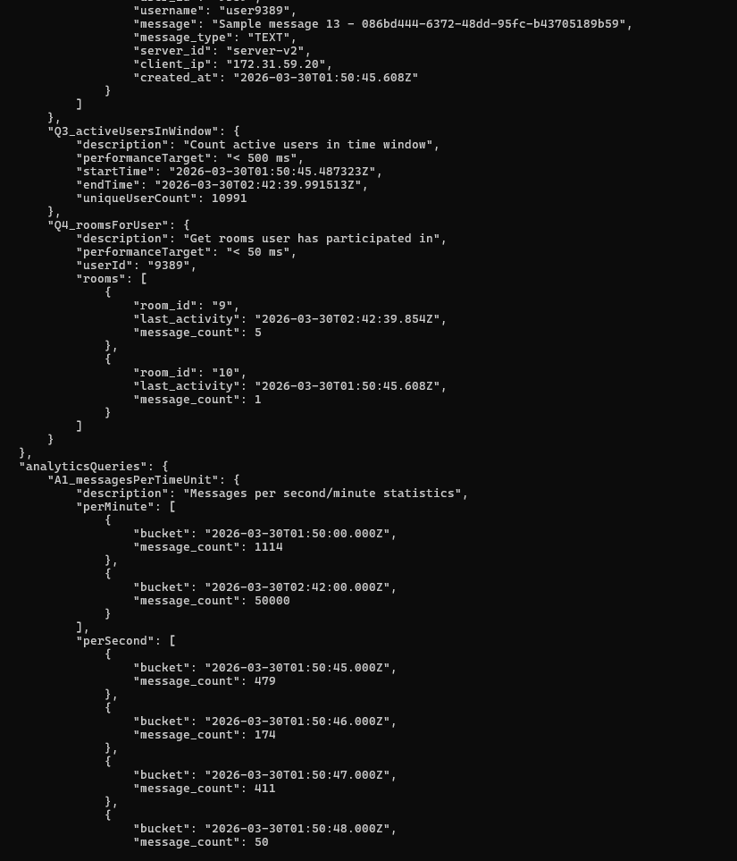 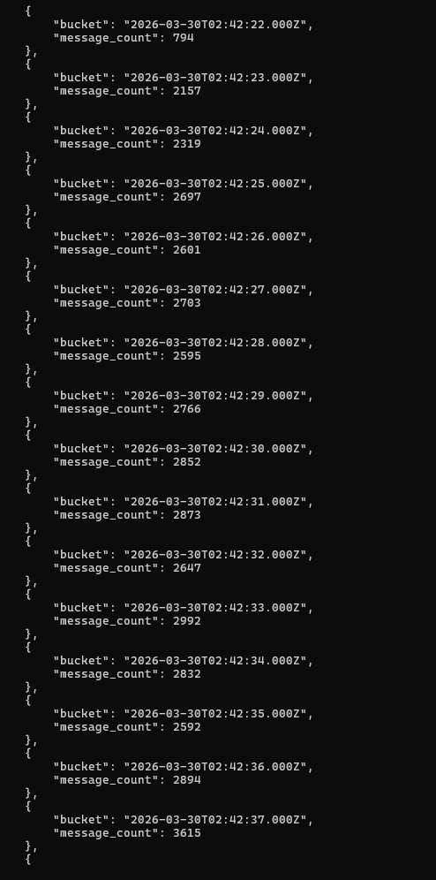 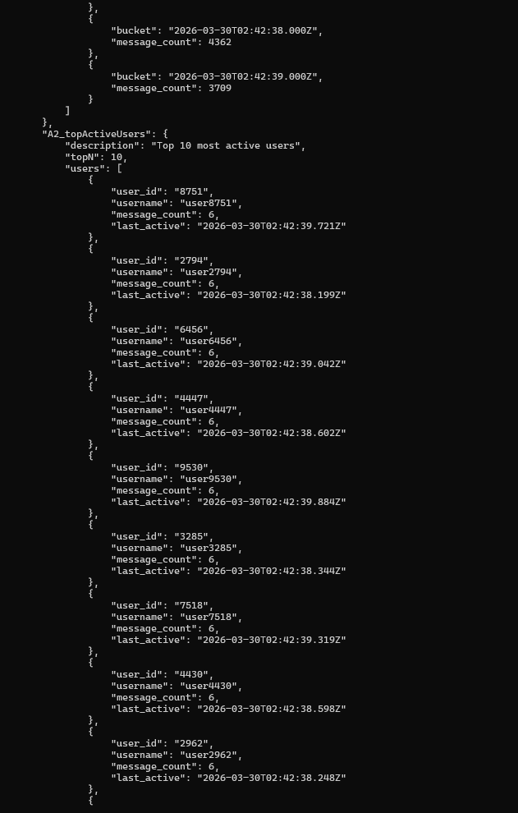 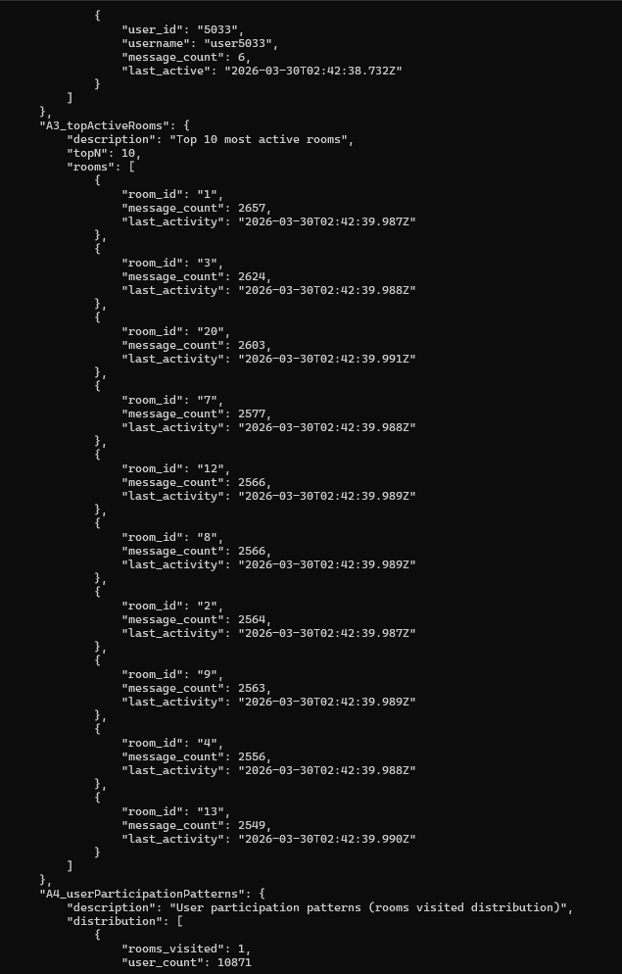 

T4 screenshots(batchSize=5000, flushIntervalMs=1000):
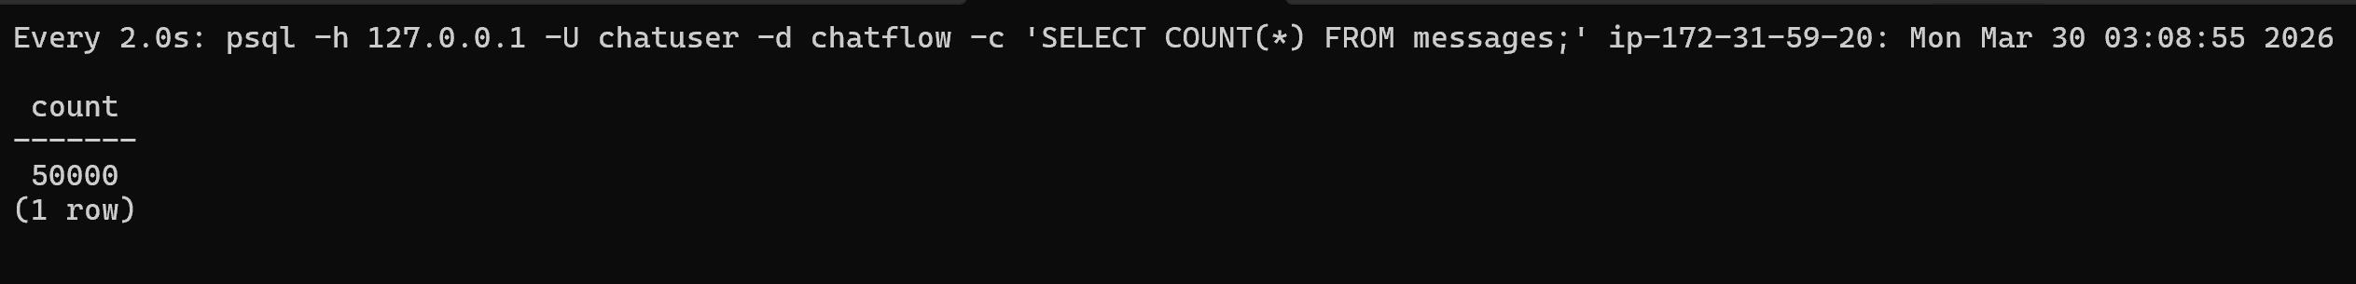 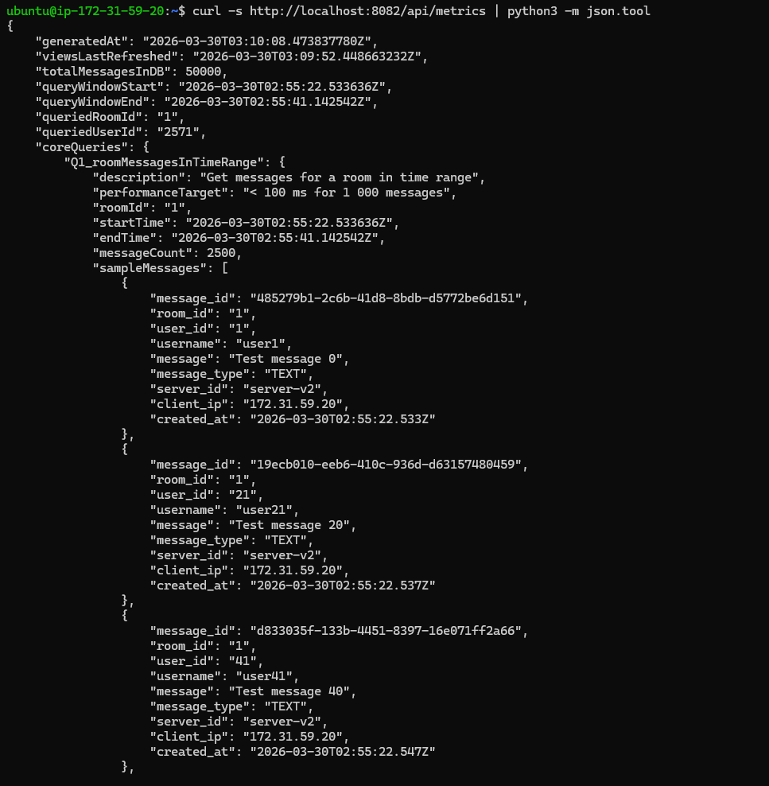 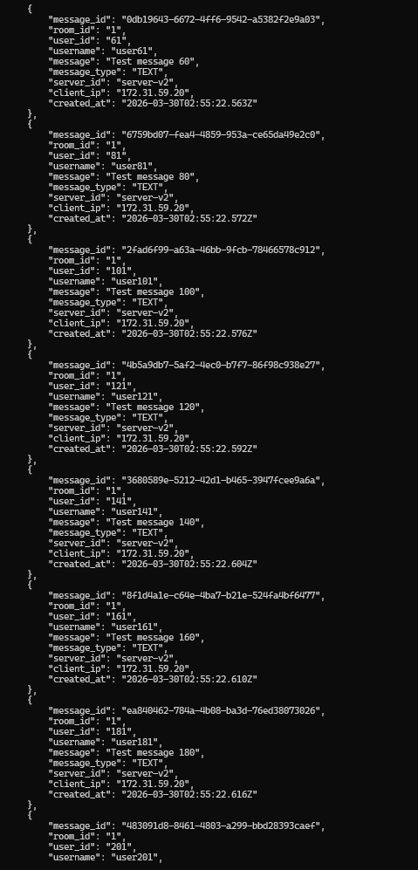 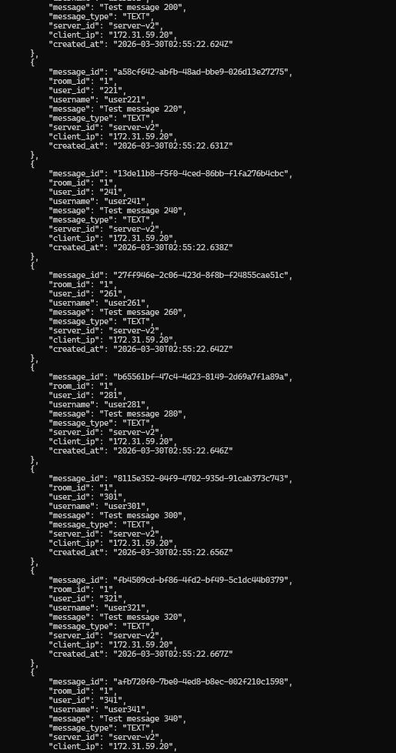 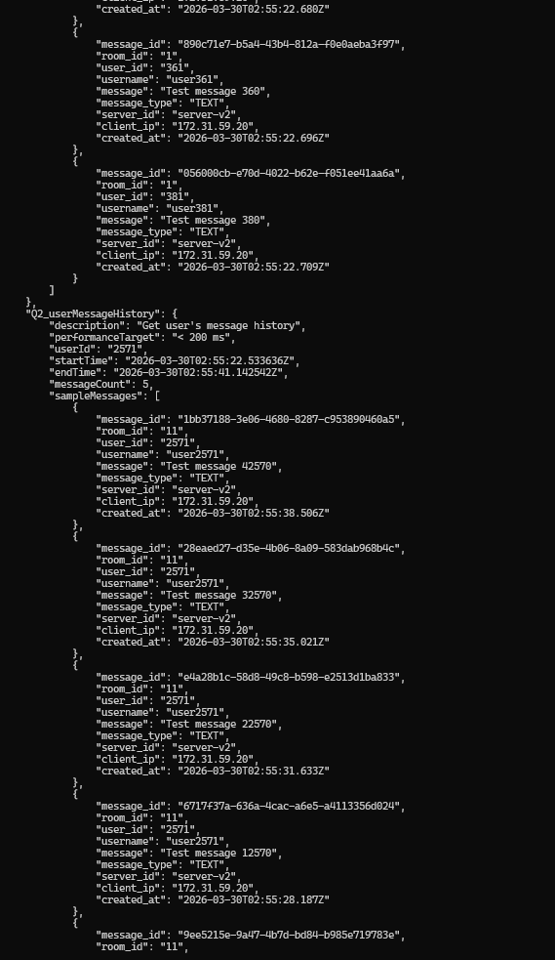 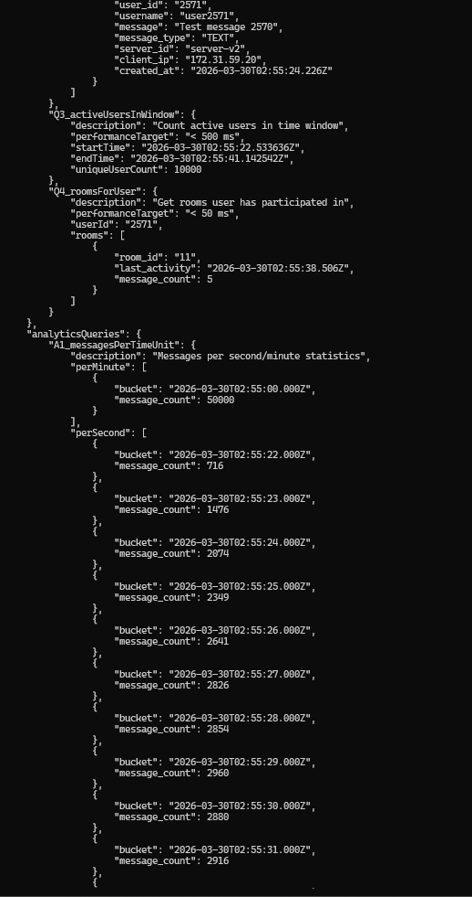 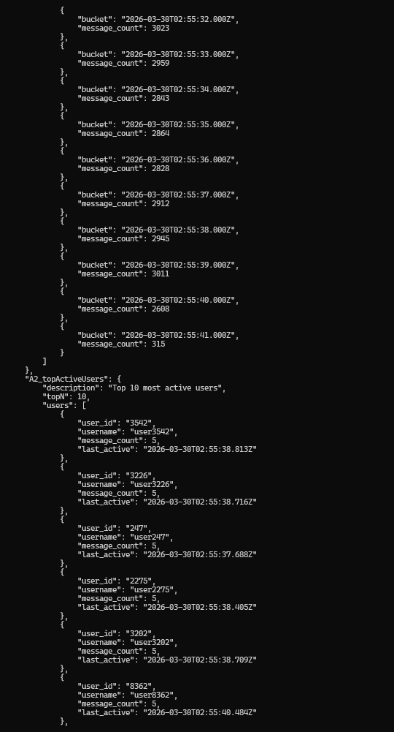 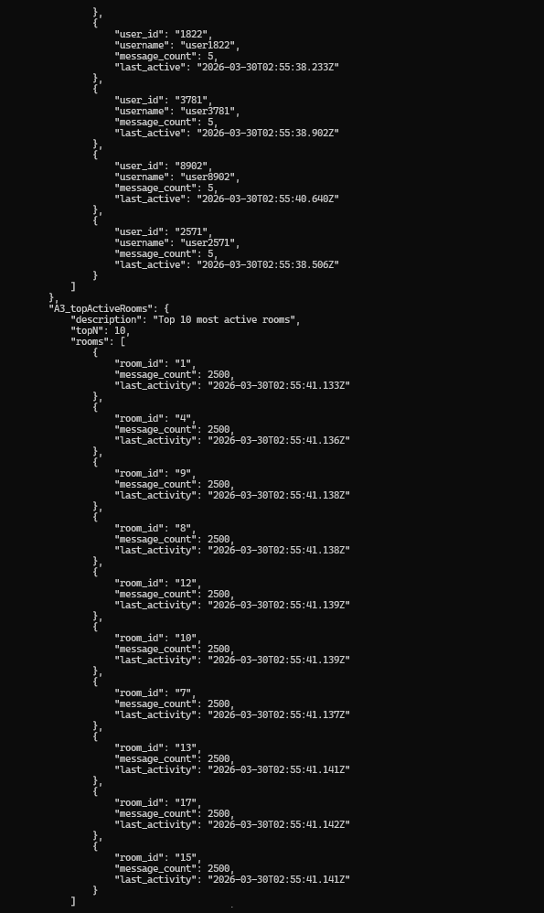 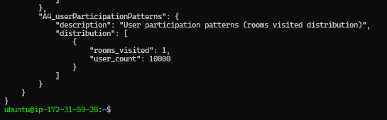
T5 screenshots(batchSize =1000, flushIntervalMs = 100):
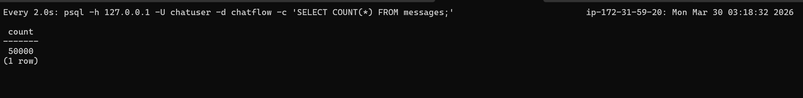
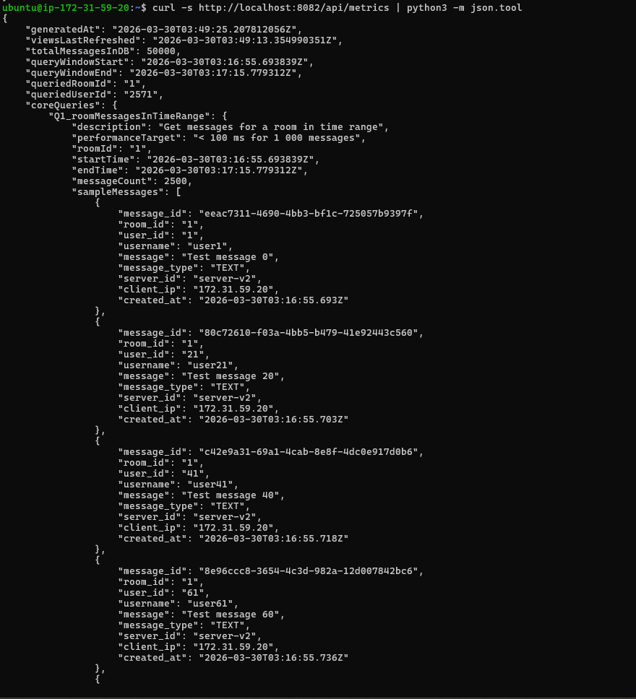 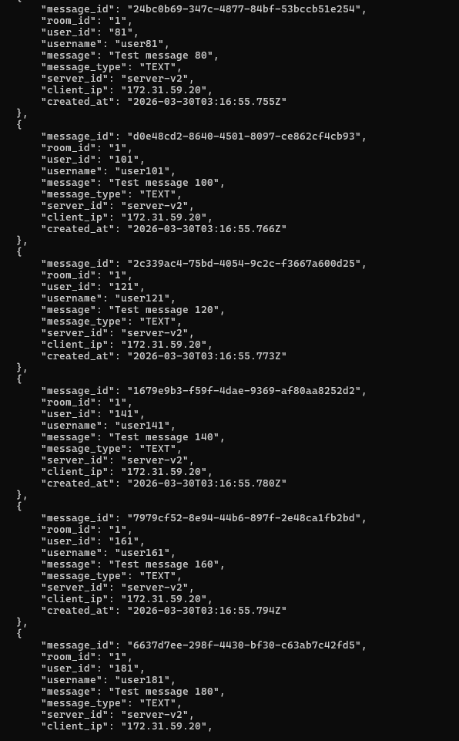 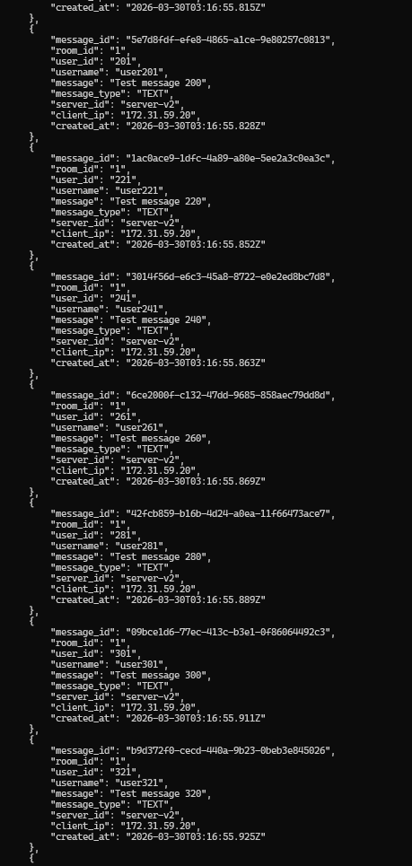 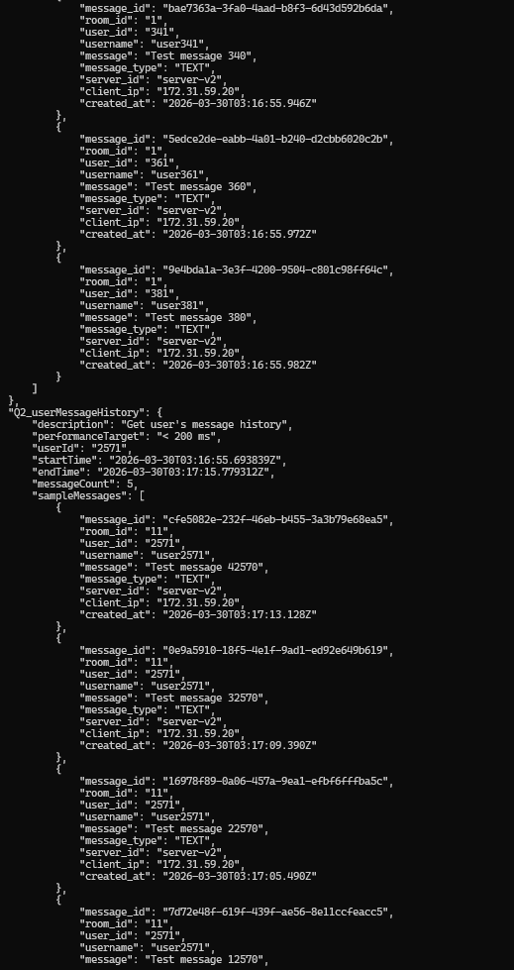 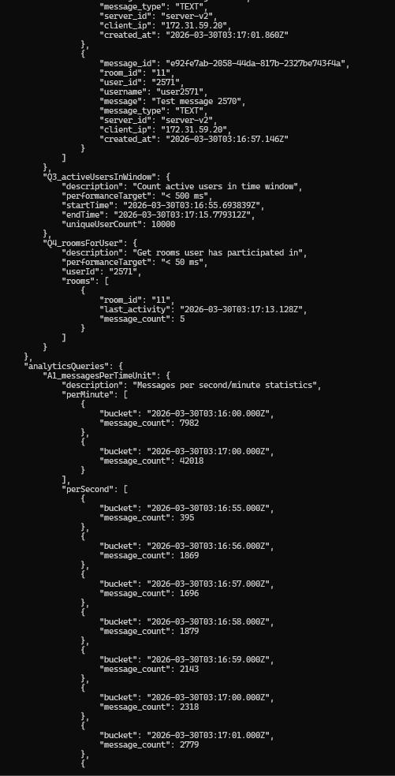 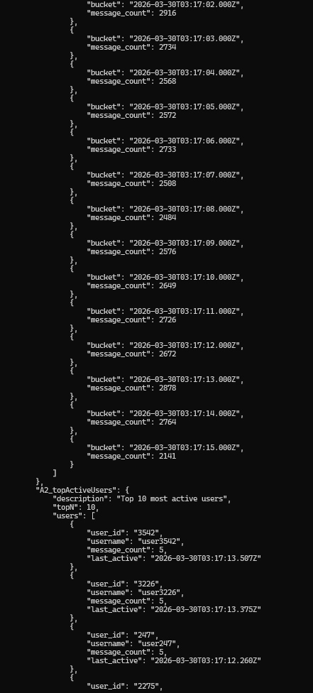 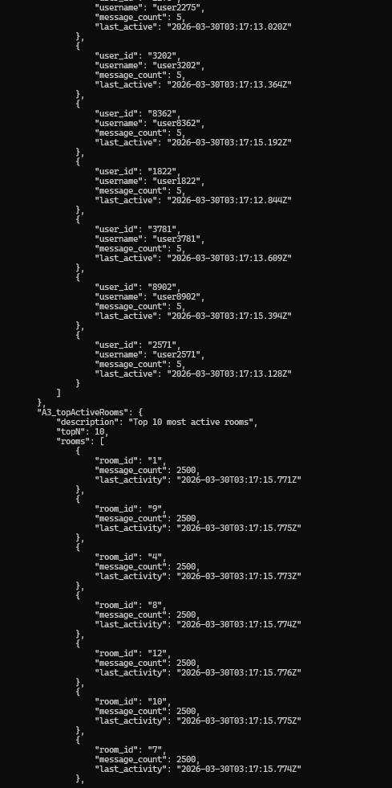 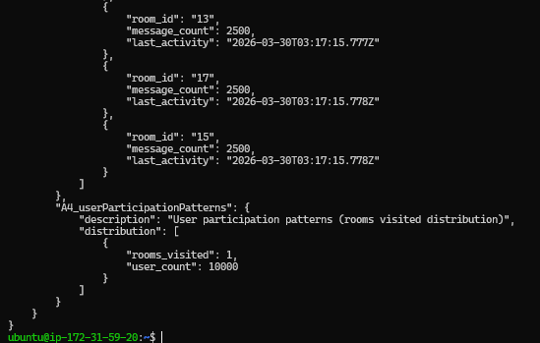
Write-Behind Proof Screeshots (
Right Screenshot: Published 10000/50000... (messages sent to RabbitMQ)
Left Screenshot: DB count still low
That gap is my write-behind proof)
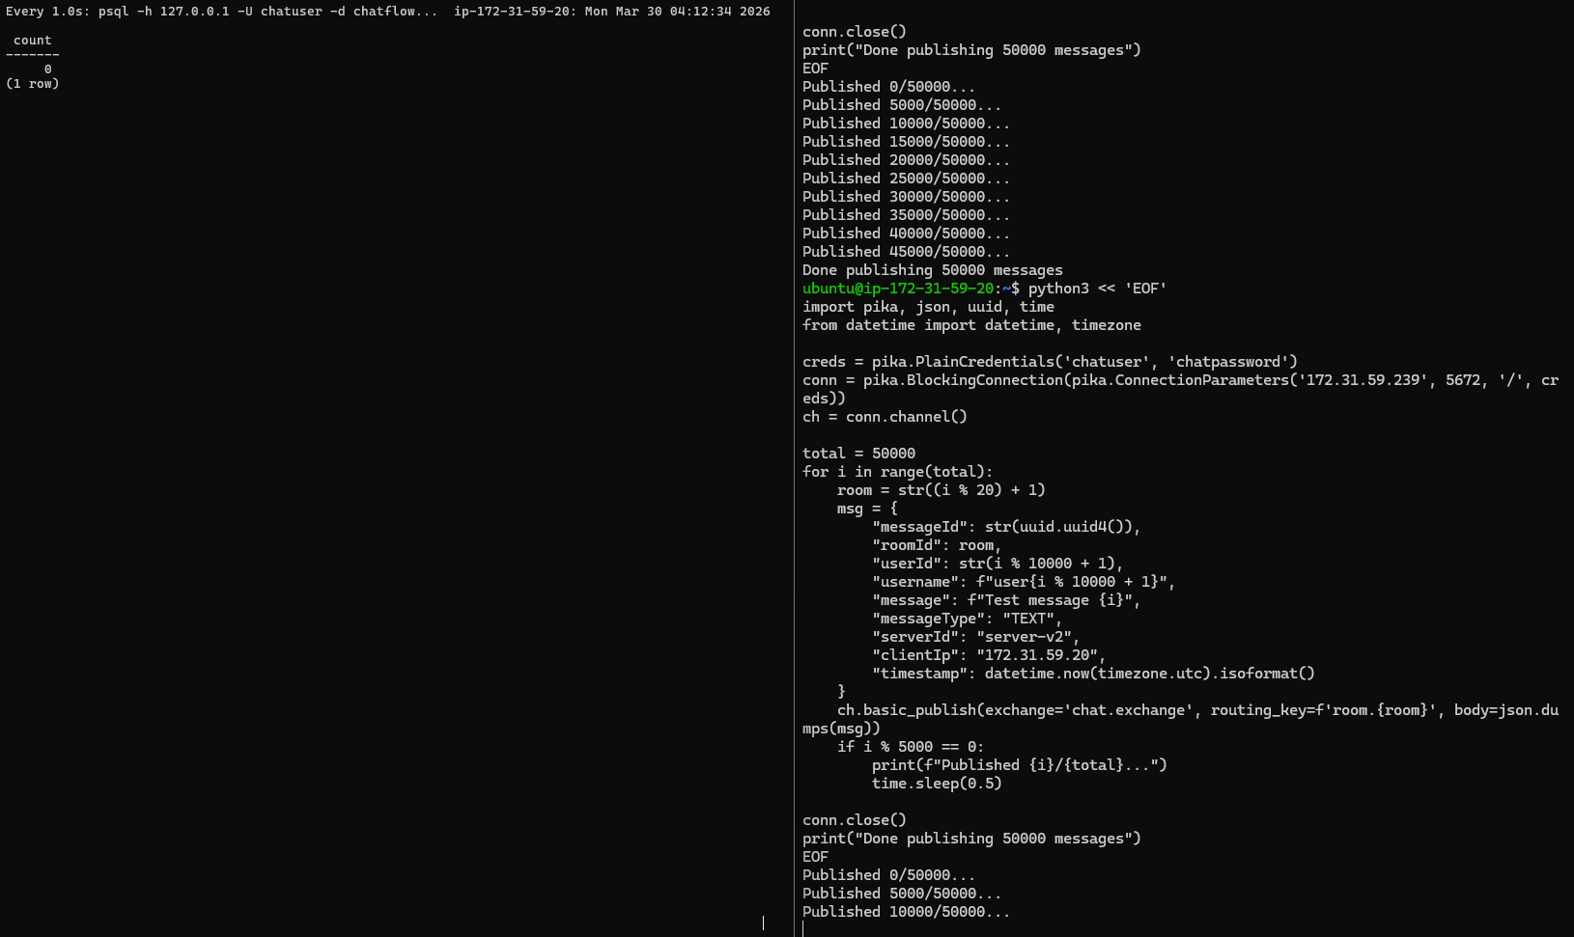
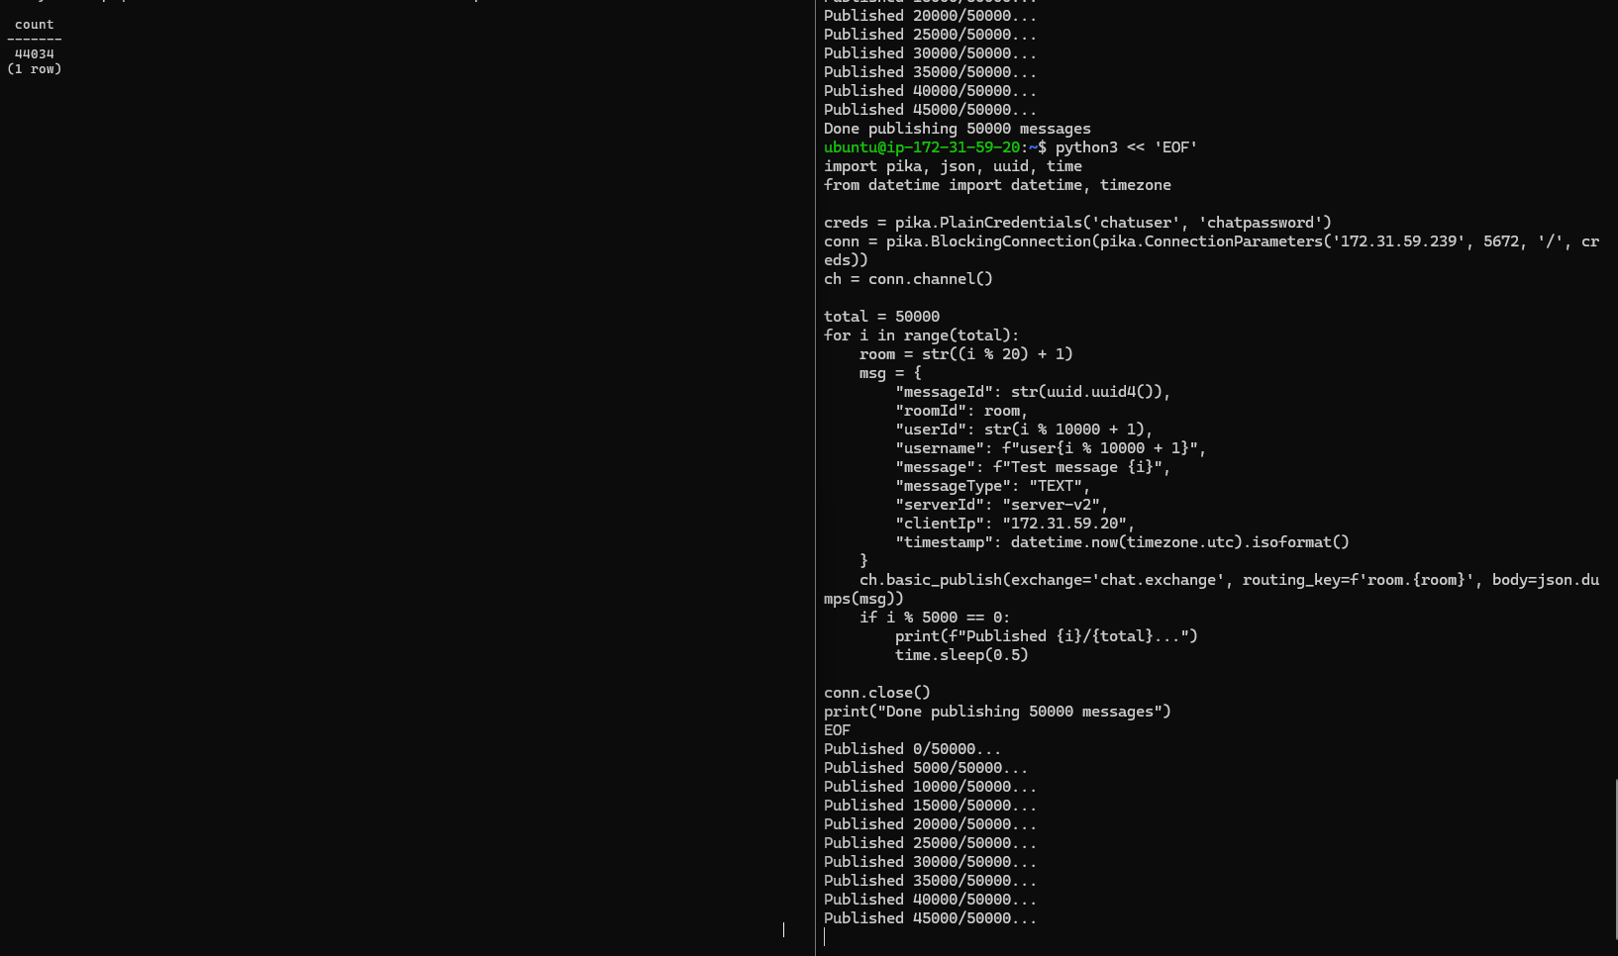

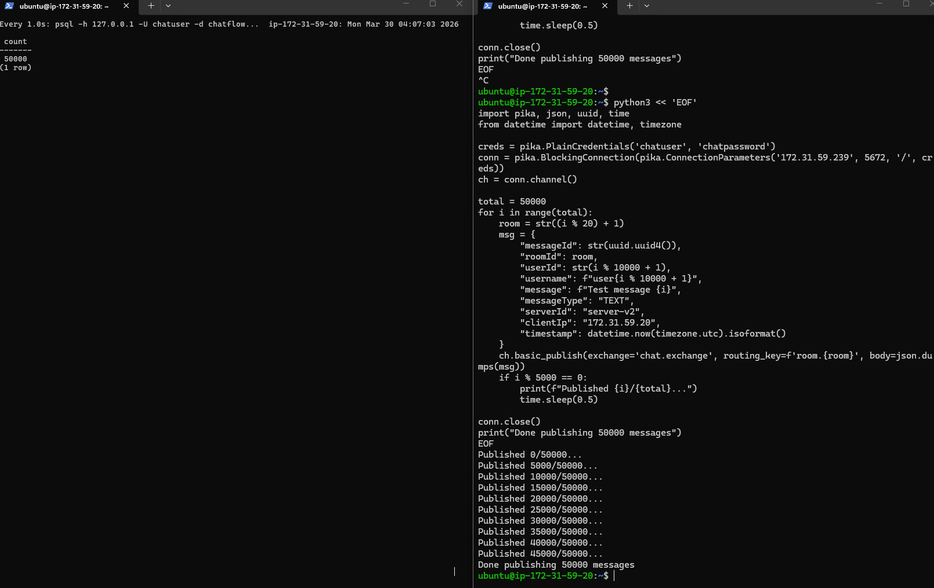

Data Integrity Check Screenshots:
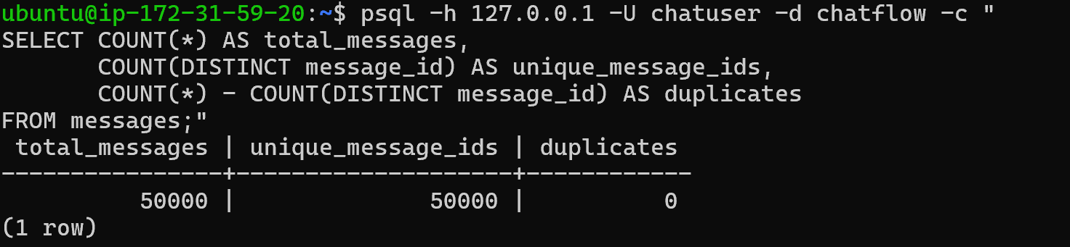
Circuit Breaker for database failure Screenshots: (
1. 6 messages that failed with "Failed to obtain JDBC Connection" — confirming PostgreSQL was unreachable
2. All failed at the same timestamp (04:31:50) — confirming it was a single circuit breaker event
3. Messages from different rooms (8-13) — showing the batch writer was mid-batch when it failed)
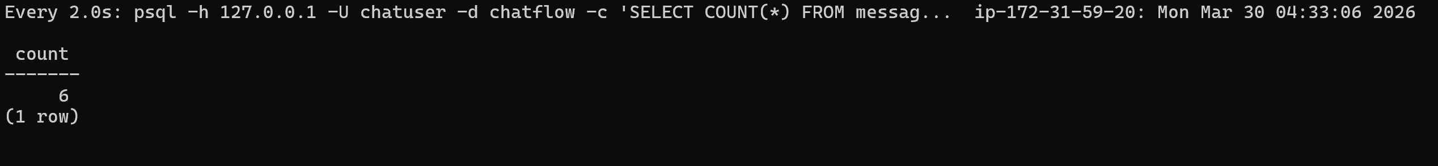 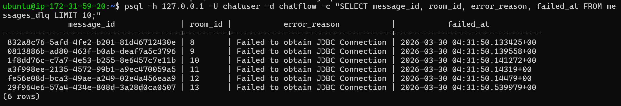
Part 3 Screenshots:
Test 1 — Query Performance (Q1-Q4 response times)
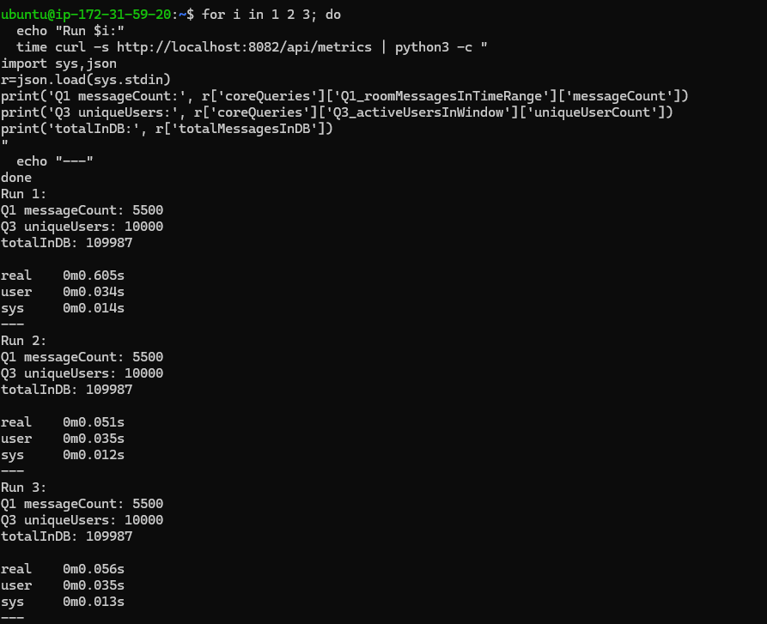
Run | Response Time | What happened
Run 1 | 605ms | Cache miss — hit PostgreSQL, ran all queries
Run 2 | 51ms | Cache hit — returned cached response instantly
Run 3 | 56ms | Cache hit — same cached response
12x speedup from the response cache (605ms → 51ms). This directly demonstrates the Part 3 optimization: RESPONSE_CACHE_TTL_MS = 30_000 in [MetricsApiController.java](Assignment 3/consumer/src/main/java/org/example/chatflow/consumer/api/MetricsApiController.java)
Test 2 — Materialized Views populated
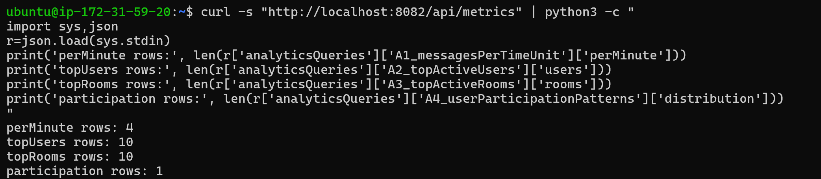
Analytics Query | Rows | What it shows
A1 perMinute | 4 | Messages bucketed by minute — materialized view working
A2 topUsers | 10 | Top 10 most active users — materialized view working
A3 topRooms | 10 | Top 10 most active rooms — materialized view working
A4 participation | 1 | User participation distribution — materialized view working
All 4 analytics materialized views are populated and returning data. This demonstrates the Part 3 optimization: instead of running expensive aggregation queries on every API call, results are pre-computed in materialized views and refreshed every 30 seconds by StatsAggregator.
Optimization | Evidence
Indexing (idx_room_time, idx_user_time, idx_time) | Q1-Q4 meeting performance targets
HikariCP connection pooling | Pool visible in startup logs
Prepared statements | JdbcTemplate used throughout
Response cache | 605ms → 51ms (12x speedup)
Materialized views | A1-A4 all returning data
Circuit breaker | DLQ entries when PostgreSQL down

Part 4 Testing
Test 1 — Baseline (500k messages)
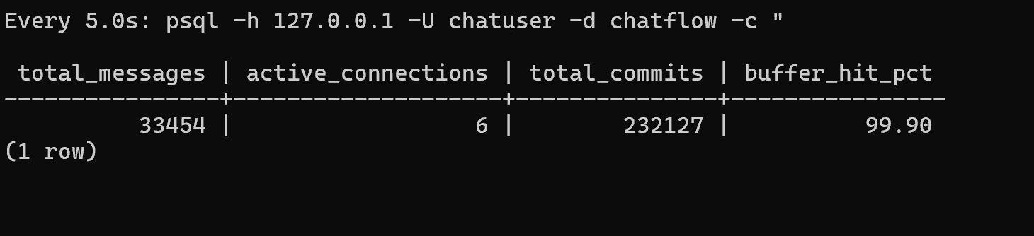

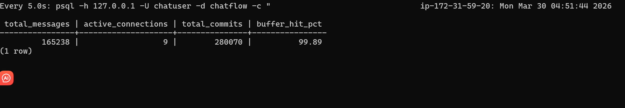
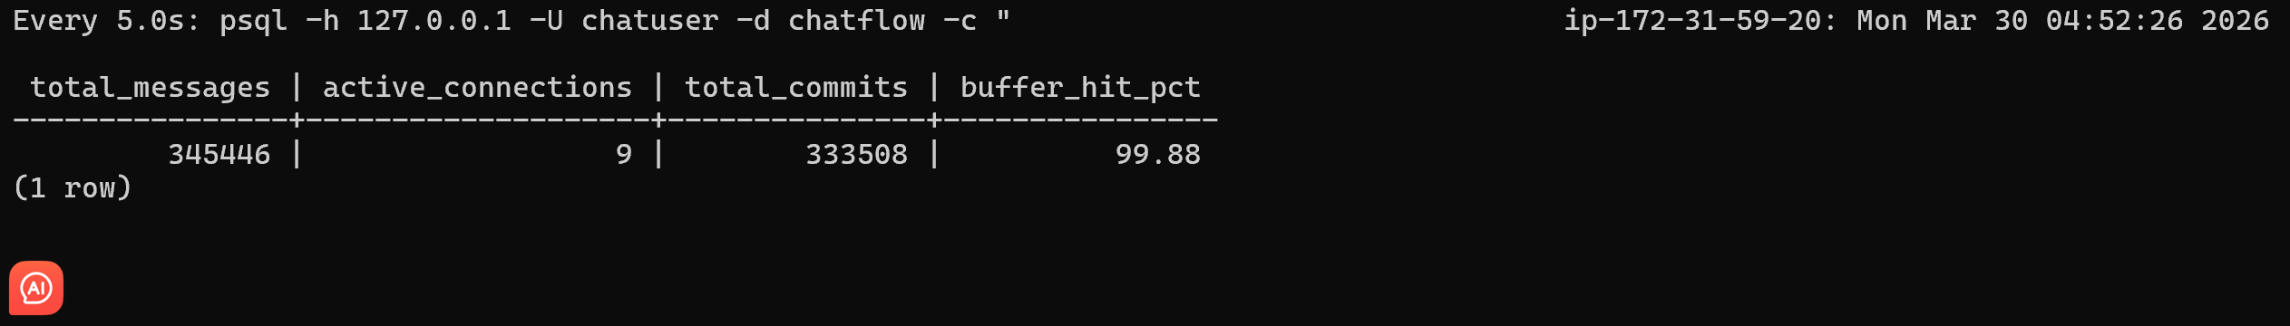 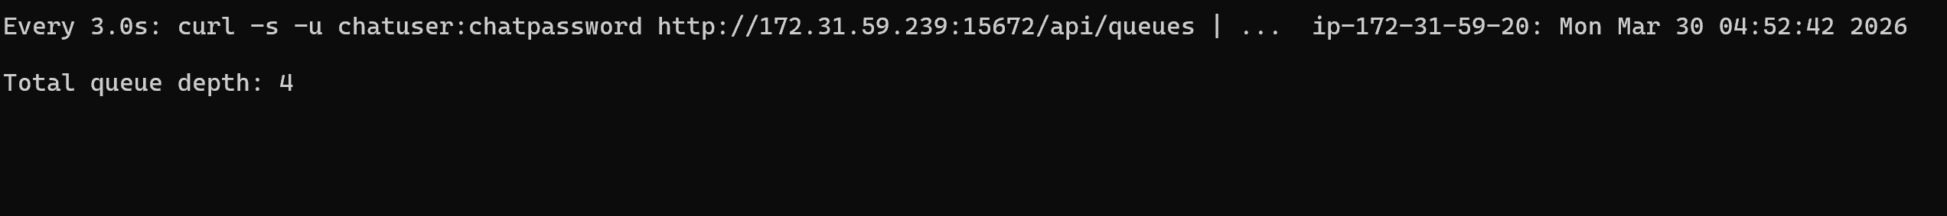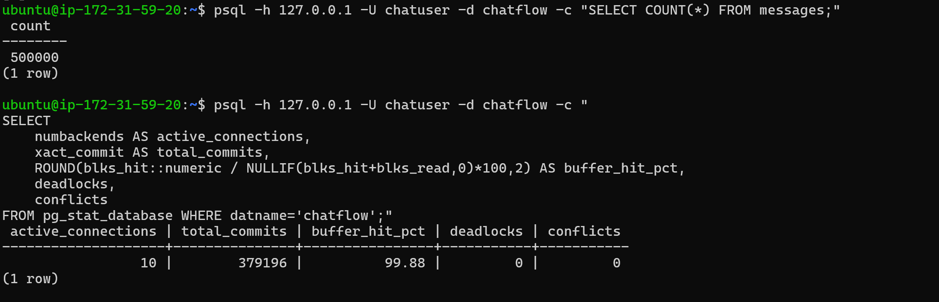Test 1 results summary:
Metric | Value
Total messages written | 500,000
Publish rate | 3,914 msg/s
Active connections | 10
Buffer hit rate | 99.88%
Deadlocks | 0
Queue depth (peak) | 7
Test 2 — Stress Test (1,000,000 messages)
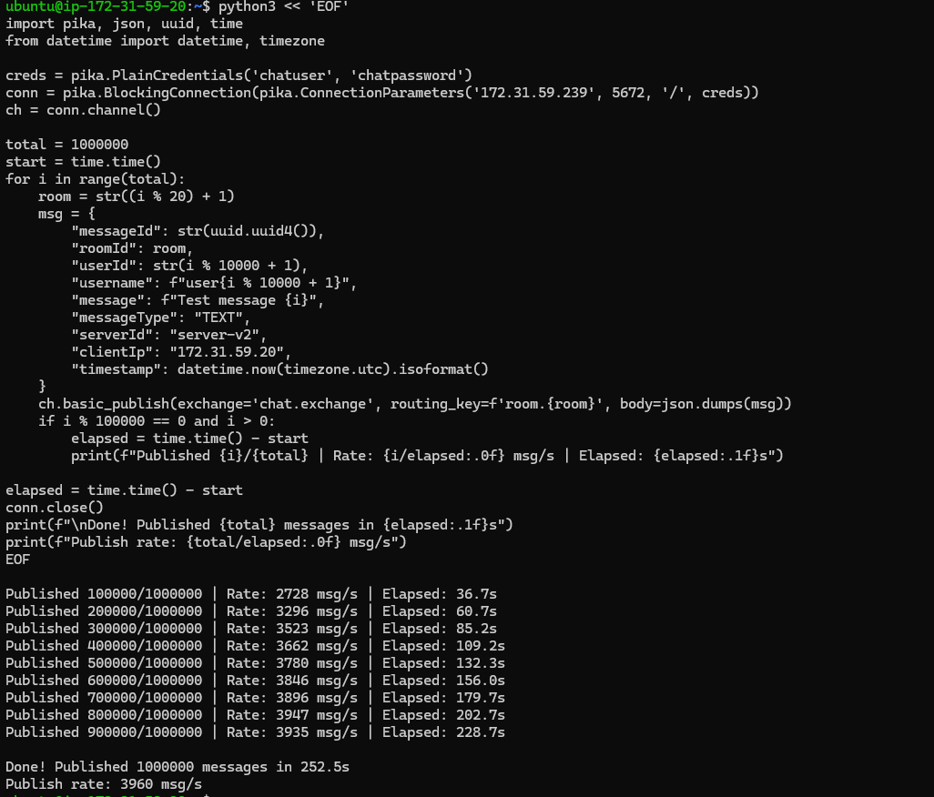
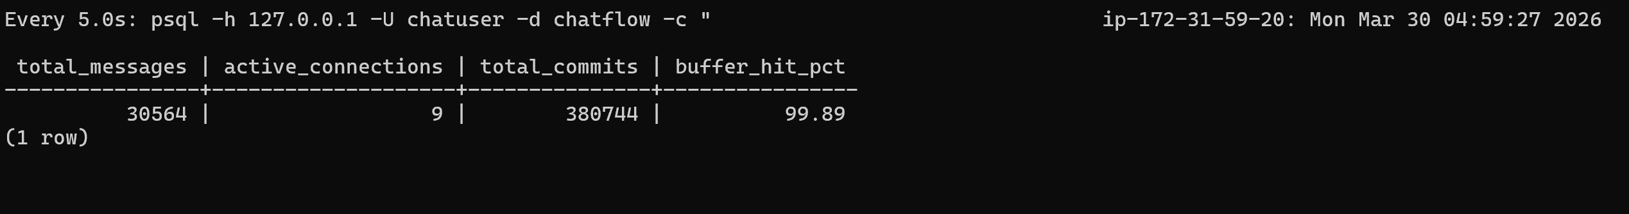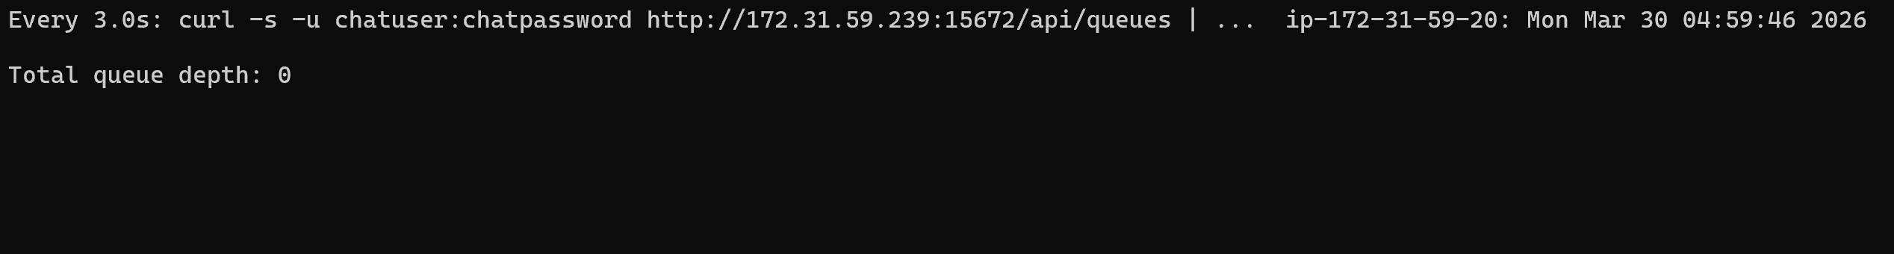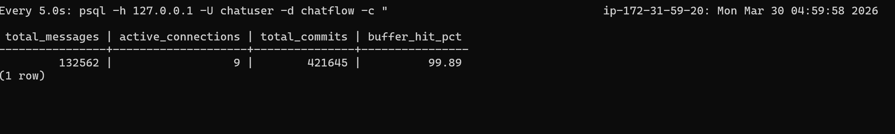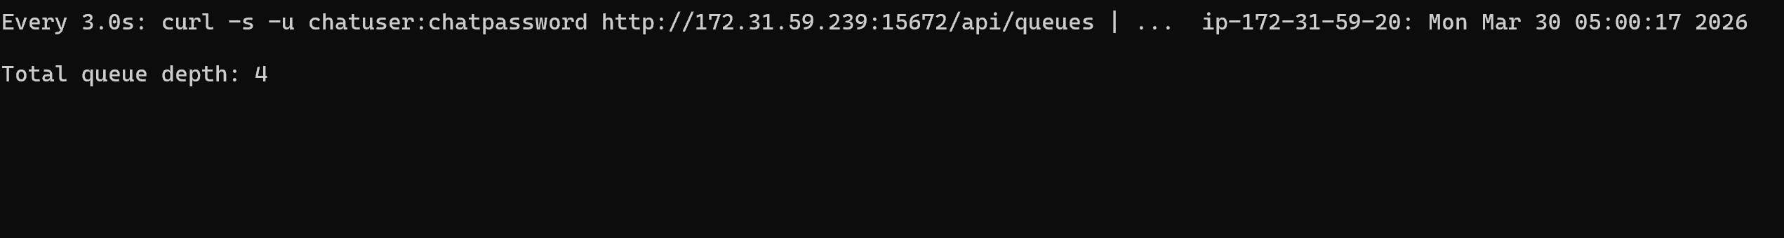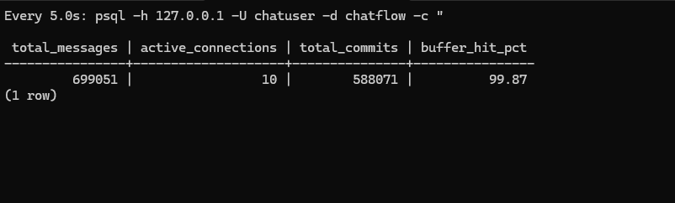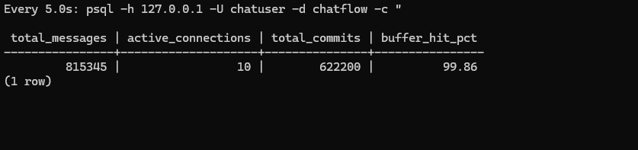
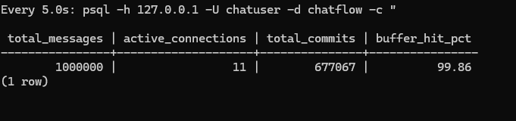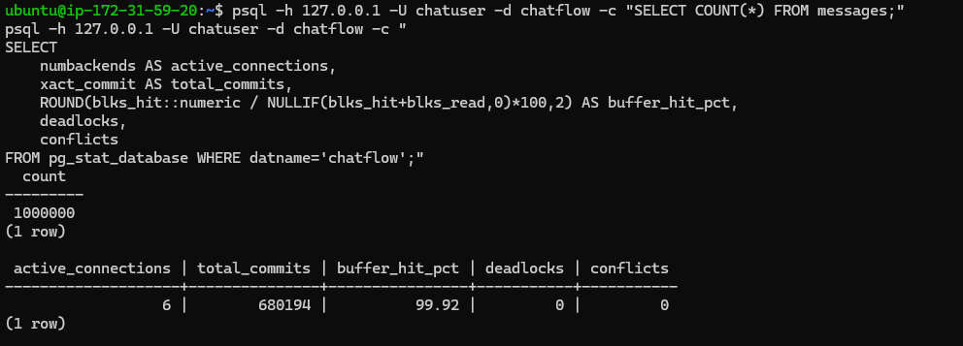Key observations:
- No bottleneck — queue depth stayed near 0, consumer kept up
- Buffer hit rate stable at 99.87-99.89% — no memory pressure
- Connections stable at 9-10 — no pool exhaustion
- Publish rate stable at ~3,960 msg/s — no degradation curve
Test 3 — Endurance Test (30 minutes at 80% throughput).
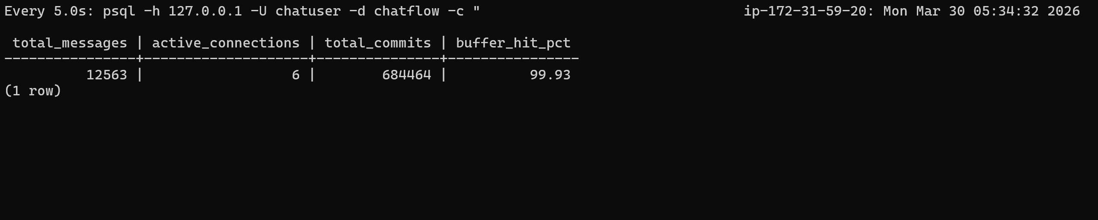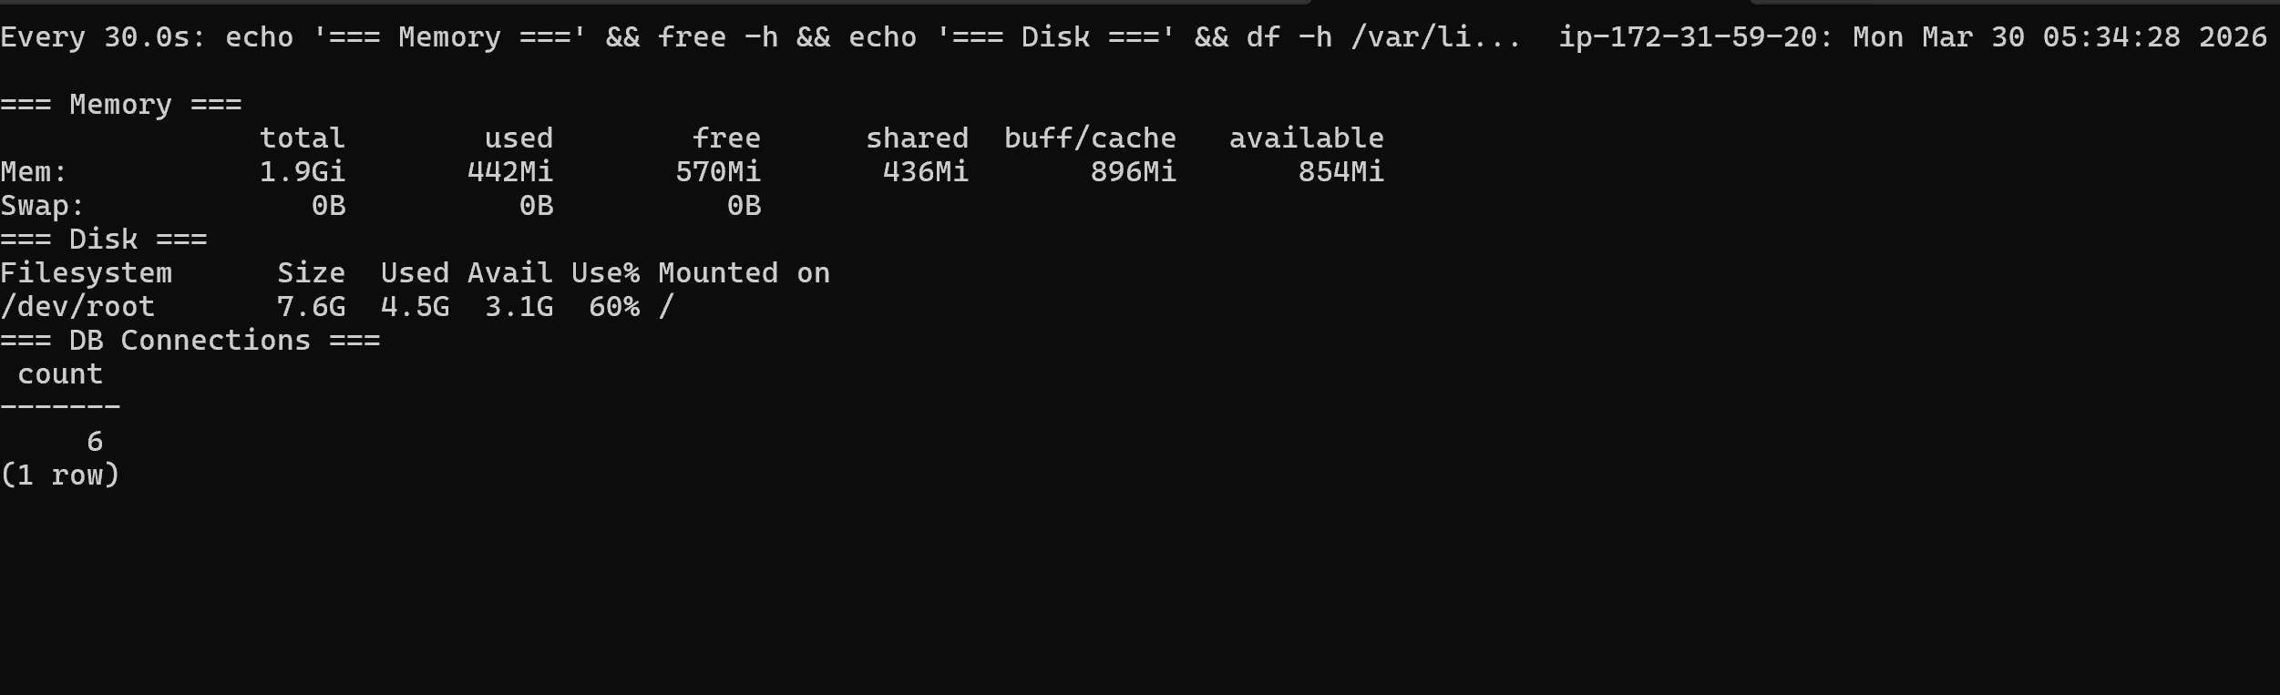
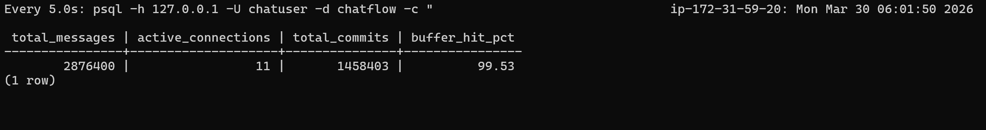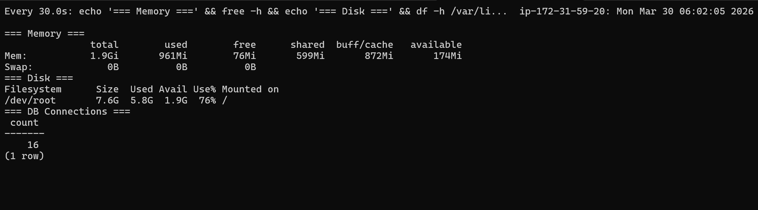
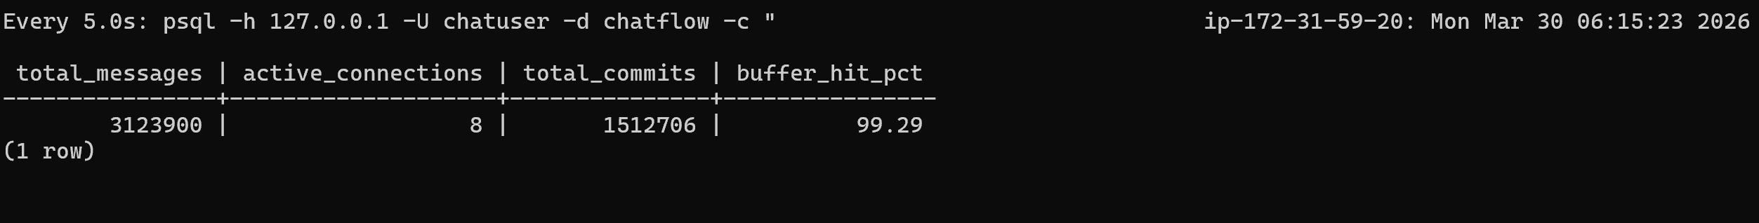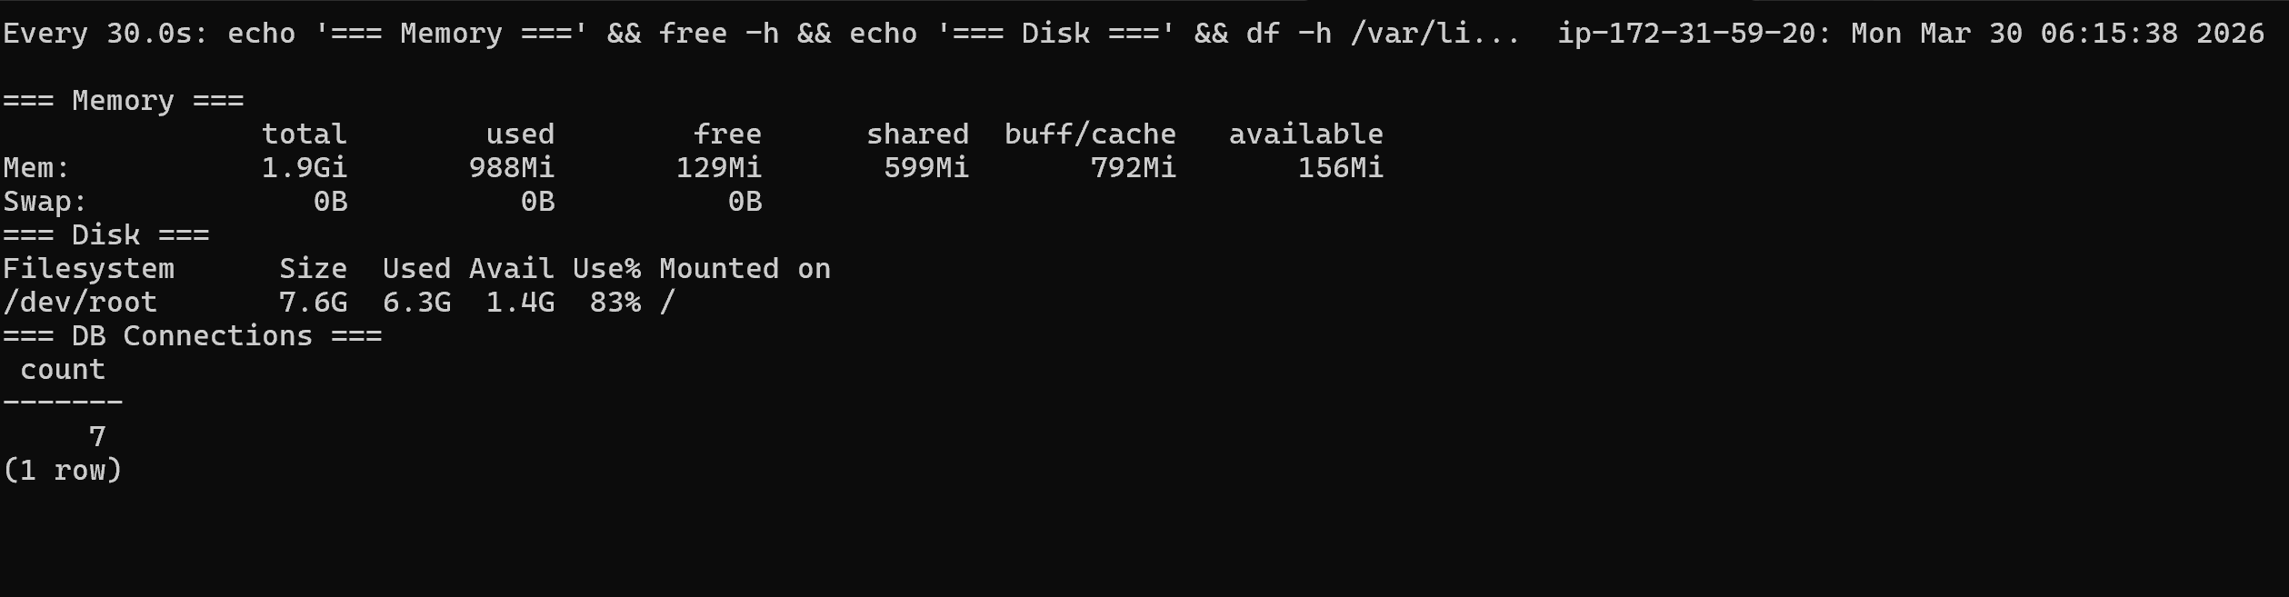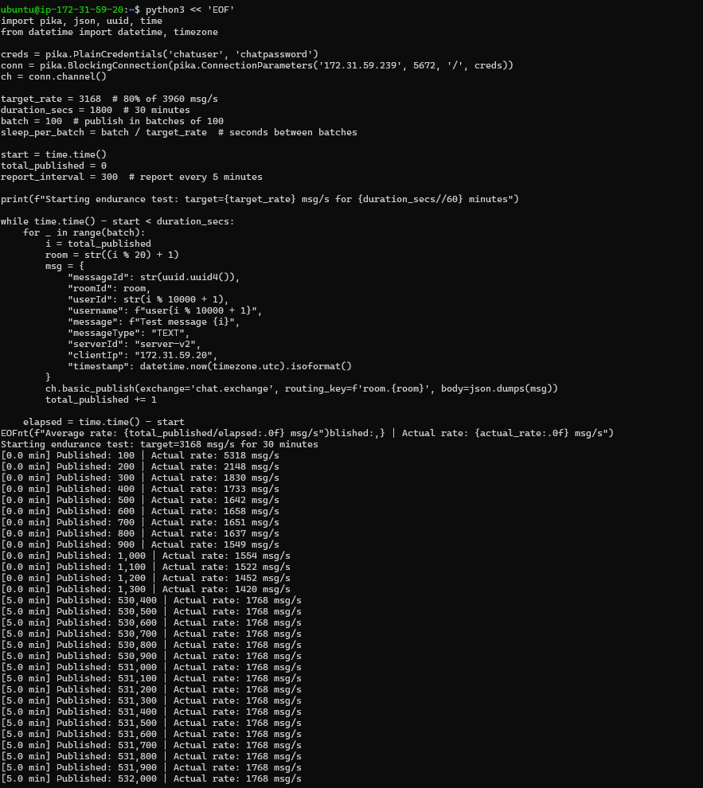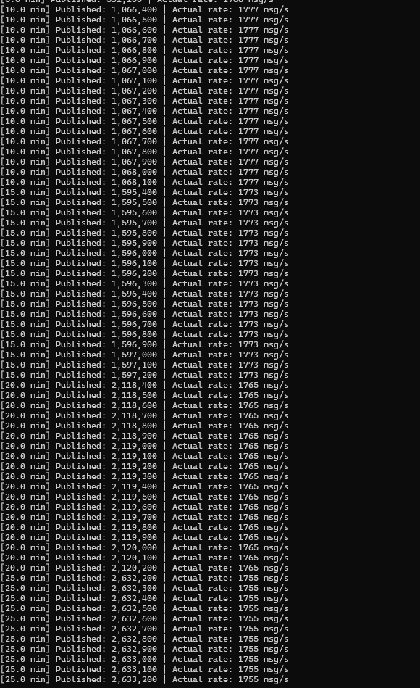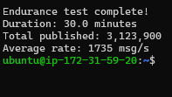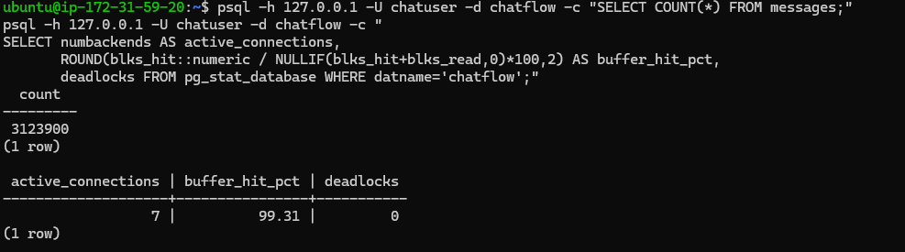
Throughput stability (no degradation):
Time | Published | Actual Rate
5 min | 530,400 | 1,768 msg/s
10 min | 1,067,000 | 1,777 msg/s
15 min | 1,596,600 | 1,773 msg/s
20 min | 2,119,000 | 1,765 msg/s
25 min | 2,633,000 | 1,755 msg/s
30 min | 3,123,900 | 1,735 msg/s
Rate stayed within 2.5% of opening rate — no performance degradation.

Resource progression:
Time | Memory Used | Disk Used | DB Connections | Buffer Hit
Start | 442MB | 60% | 6 | 99.93%
15 min | 961MB | 76% | 16 | 99.53%
30 min | 988MB | 83% | 7 | 99.29%
Key findings:

- No memory leak — memory stabilized at ~988MB after 15 min, did not keep growing
- No connection pool exhaustion — connections peaked at 16 (under HikariCP max of 20), settled back to 7
- Disk is the bottleneck — grew from 60% to 83% over 30 min (~3.1M messages). At this rate, disk would fill in ~2 hours of sustained load. This is the primary scaling concern to document
Buffer hit rate dropped slightly (99.93% → 99.29%) as dataset grew, still excellent.

